Directions to site at Ellerslie
Access from Greenlane Rd is at either set of lights. Right or straight at the first roundabout. Left at the second roundabout onto Palm Tree Lane.
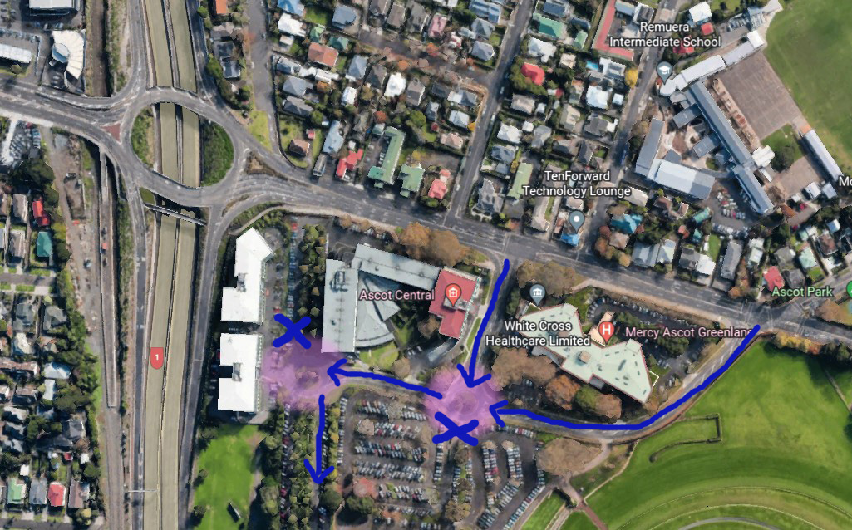

Keep to the right of the Palm Tree gate coned lane and enter through the main gate. Follow the green arrows on the below map to your designated site.
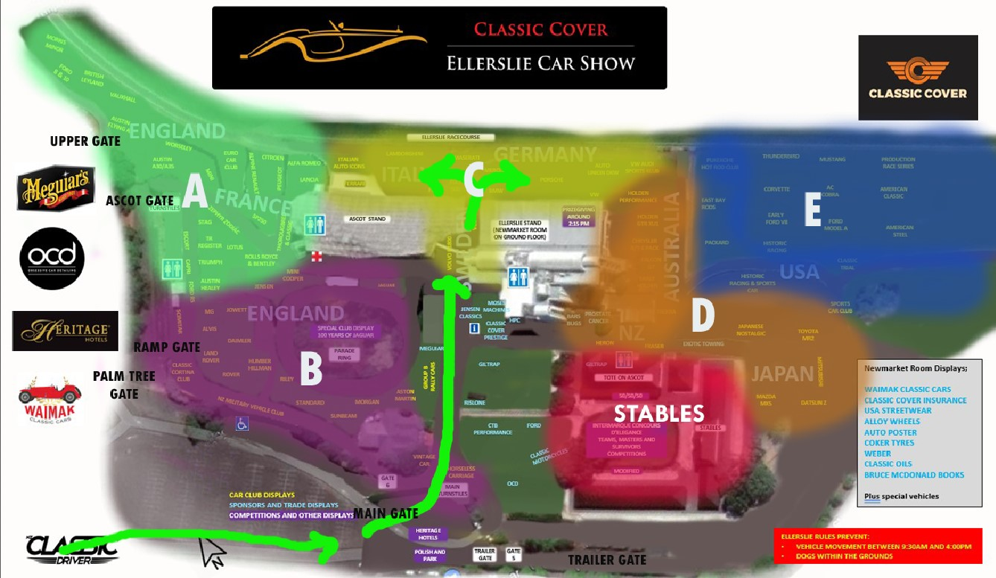

HAVE YOUR WINDSCREEN STICKER ON.

